Nautilus
Widget Engine SDK

Référence : | NG_BYTEL_NAUTILUS_SDK Documentation
Version : | 0.1
Etat : | DRAFT
Date de diffusion : | 31/05/2011

Fiche signalétique

Titre du document | Widget Engine SDK
Nom du projet | Nautilus
Version | 0.1
Date de diffusion | 31/05/2011
Référence | NG_BYTEL_NAUTILUS_SDK Documentation
Nom du fichier informatique | NG_BYTEL_NAUTILUS_SDK Documentation [EN]_v1.0_20110531.docx
Nombre de pages | 18
Nombre d’annexes | 0
Nombre de pièces jointes | 0
Etat du document | DRAFT

REDACTION
 | NOM | FONCTION | DATE
Rédigé par :
Validé par :

DIFFUSION
SOCIETE | NOM | Pour validation | Pour application | Pour information

HISTORIQUE DES MODIFICATIONS
DATE | AUTEUR | VERSION | OBJET | CHAPITRES
 |  |  |  | Créés | Modifiés | Effacés
26-05-11 | Thomas MOLLARD | 0.1 | Draft
30-05-11 | Julien BRENELIERE | 0.2 | English review
31-05-11 | Thomas MOLLARD | 0.3 | Adding OpenSSL dependencies & update Main window description

TABLE OF CONTENTS
1 Purpose 5
2 Description 6
2.1 User interface - Main window 6
2.1.1 Refresh button 6
2.1.2 Stop button 6
2.1.3 SMEG Version selection combo box 6
2.1.4 Key connectivity button 6
2.1.5 Network connectivity status button 7
2.1.6 Driving state button 7
2.1.7 SMEG settings button 7
2.1.8 Debug console button 7
2.1.9 JavaScript console button 7
2.1.10 “Let’s script it” button 7
2.1.11 Cache usage 8
2.1.12 Clear cache button 8
2.1.13 Webview 8
2.1.13.1 Widget engine layout 8
2.2 User interface - SMEG settings dialog 8
2.2.1 Global buttons 9
2.2.1.1 OK button 9
2.2.1.2 Cancel button 9
2.2.1.3 Apply button 9
2.2.2 Position tab 10
2.2.3 Source tab 11
2.2.4 Car tab 12
2.2.5 Engine tab 13
2.2.6 Dongle tab 14
2.2.6.1 Infos tab 14
2.2.6.2 Storage tab 15
2.3 Debug console 16
2.4 User interface - JavaScript console 17
2.5 User interface – Let’s Script It! 18
3 Technical 19
3.1 Prerequisite 19
3.1.1 Java 1.6 19
3.1.2 OpenSSL 19
3.2 Ports in use 19
3.3 Tested environments 19
4 Widget development 20
4.1 Back button 20
4.2 Configuration button 20
4.3 Events propagation 20
4.3.1 Network status update 20
4.3.2 Driving status update 21
5 End of the document 22

- Purpose
This document intends to describe the widget engine Software Developer Kit.

- Description
  - User interface - Main window
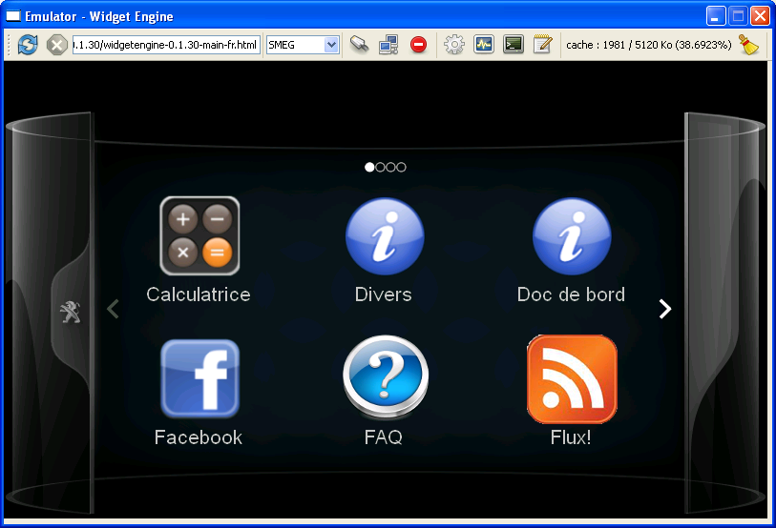
13
11
10
8
7
9
6
5
4
3
12
2
1
    - Refresh button
Reload the content of the emulator
    - Stop button
Stop the processing of the current network request.
    - SMEG Version selection combo box
Choose the version of the SMEG.
    - Key connectivity button
Simulate the plug-unplug action for the 3G stick.

Possible states:
: The 3G stick is not connected. Click this button to simulate the connection of the stick onto the SMEG.
: The 3G stick is connected. Click this button to simulate the disconnection of the stick.
    - Network connectivity status button
Simulate the network activation-deactivation action.

Possible states:
: The stick is not connected. The network is not activated and cannot be activated.
: The stick is connected but the network is not activated. Click this button to activate the network.
: The key is connected and the network is activated. Click this button to deactivate the network.
    - Driving state button
Simulate the modification of the driving state.
Possible states:
: The car is not moving. Click this button to toggle it to on.
: The car is moving. Click this button to toggle it to off.
    - SMEG settings button
Show the SMEG settings Dialog.
    - Debug console button
Show the Debug console.
    - JavaScript console button
Show the JavaScript console.
    - “Let’s script it” button
Show the “Let’s script it” button.
    - Cache usage
Gives information about the cache usage aka the Kbytes consumed out of the available amount.
    - Clear cache button
Simulate a flush cache.
    - Webview
The Webview displays the widget engine.
      - Widget engine layout
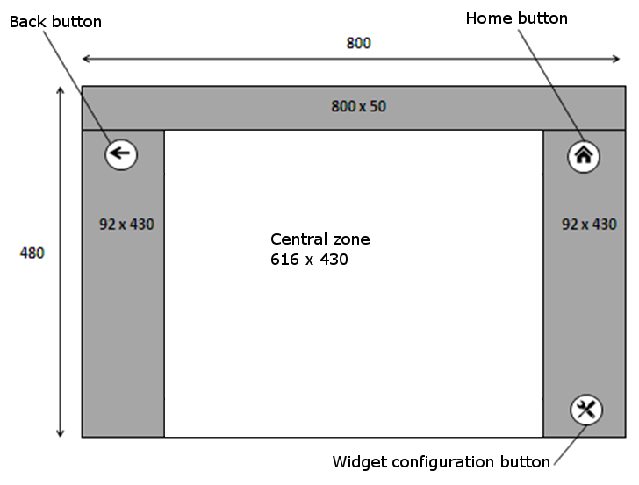
Widgets are displayed in the central zone and can use all this area.

  - User interface - SMEG settings dialog
    - Global buttons
There are three buttons on the bottom right corner of the window. Those buttons are used to validate any change done on SMEG settings.
      - OK button
: Click this button to apply any change done to the SMEG settings and to close the SMEG settings dialog.
      - Cancel button
: Click this button to cancel any change done to the SMEG settings and to close the SMEG settings dialog.
      - Apply button
: Click this button to apply any change done to the SMEG settings and to keep the SMEG setting dialog open.

    - Position tab
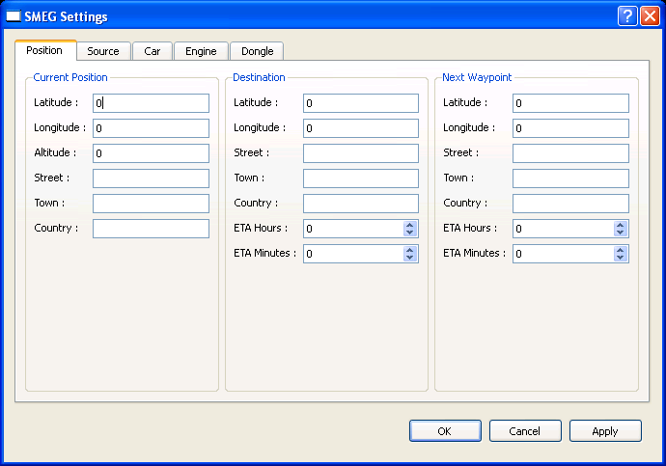

This window allows changing the settings of the navigation system:

Current Position
Destination
Next Waypoint

    - Source tab
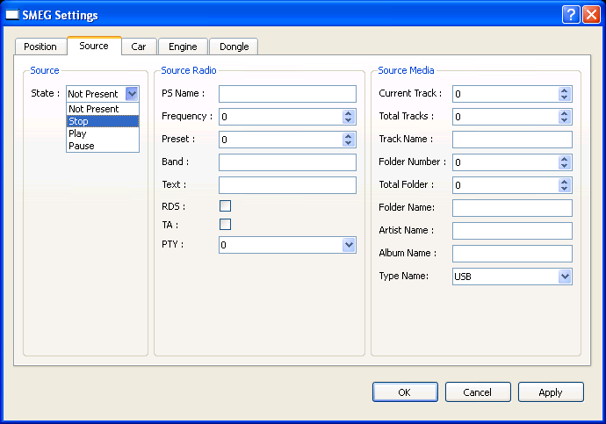

This window allows changing the settings of the media:

State of the source
Radio related settings
Other media related settings

    - Car tab
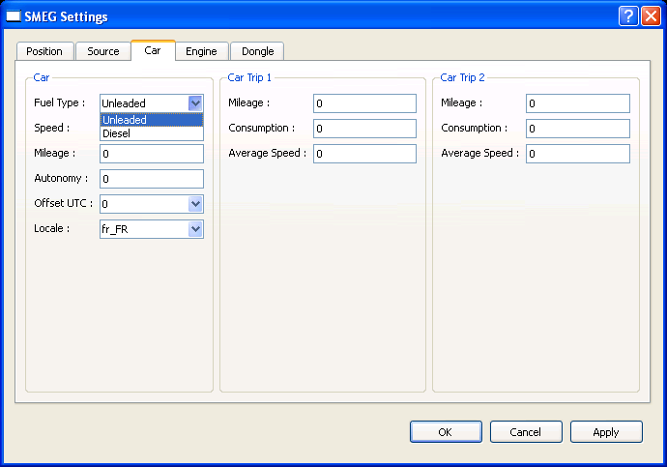

This window allows changing the settings of the car:

global settings of the car (Car block)
Last trip settings (Car Trip 1 block)
Next to last trip settings (Car Trip 2 block)

    - Engine tab
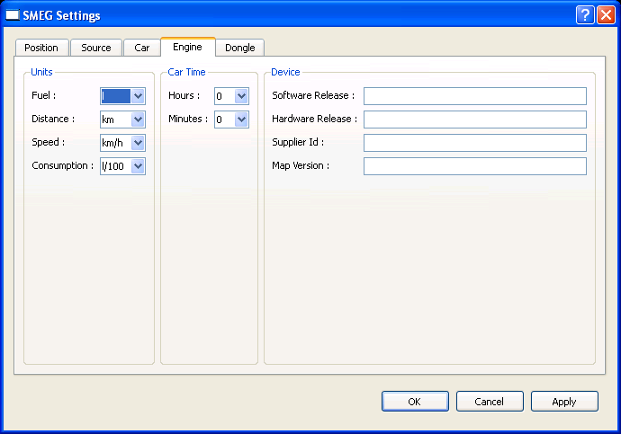

This window allows changing the settings of the car engine:

Units
Car time
Device data

    - Dongle tab
      - Infos tab
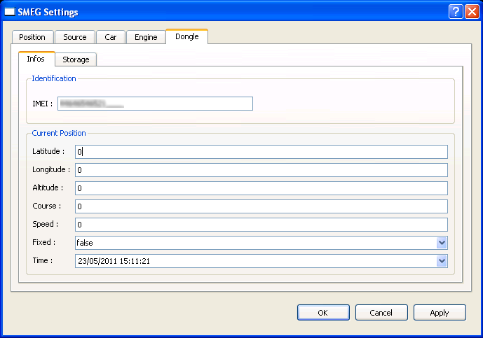

This window allows changing the main settings of the 3G stick:

IMEI
Current position

      - Storage tab
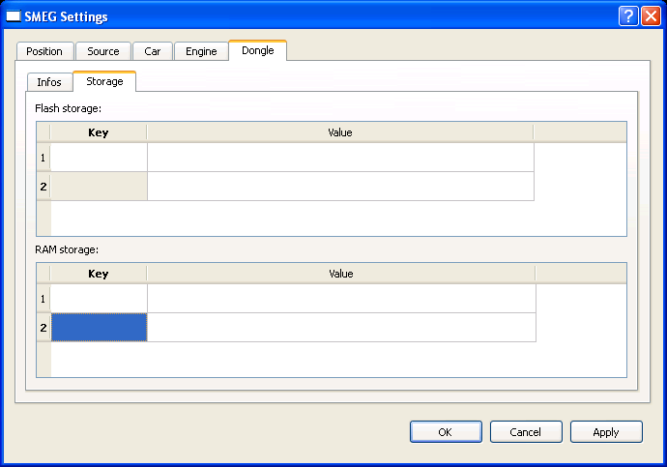

This window allows changing the storage settings of the 3G stick:

Data stored onto the flash storage through the PORTAL.storage().* APIs
Data stored in RAM only through the PORTAL.storage().* APIs

  - Debug console
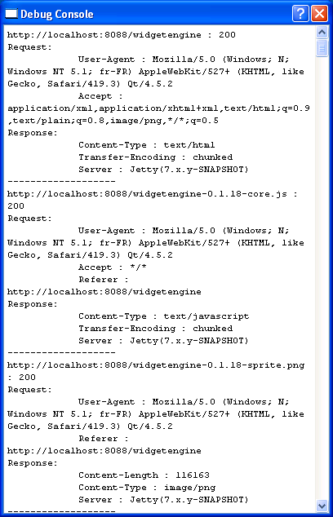

The console displays the logs of the emulator HTTP requests and their responses.
This is a read-only window.

  - User interface - JavaScript console

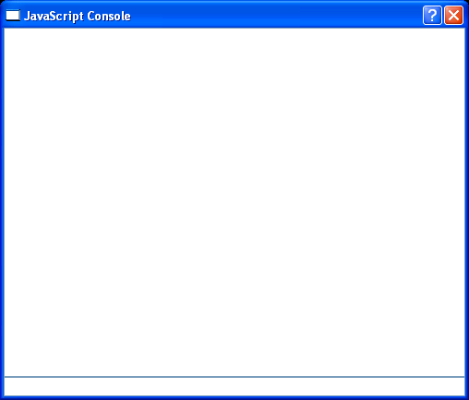

The JavaScript console window is made for the Webview. It shows the JavaScript errors that happened in the Webview.

The console has read-write settings meaning that JavaScript can be written and processed in the input field located under the console.

  - User interface – Let’s Script It!
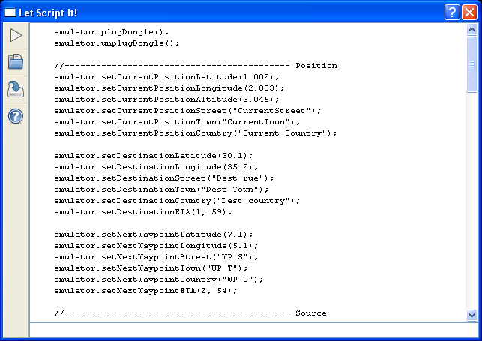

This window provides a JavaScript engine capable of interacting with the settings of the emulator. This could be handy to write out specific scenarios while testing the widgets for instance.

The available functions are described inside the window’s help button.

: run the current script
: load a script from the file system
: save the script to the file system
: show the embedded help (list of available functions) of the “Let’s Script it!” module.

- Technical
  - Prerequisite
    - Java 1.6
The minimum Java version 1.6 has to be installed on the developer system.
The 1.6 JRE can be downloaded from the Oracle website:
http://www.oracle.com/technetwork/java/javase/downloads/index.html
    - OpenSSL
The OpenSSL 32bits libraries have to be installed on the developer system.
The libraries can be found from OpenSSL website:
http://www.openssl.org/related/binaries.html

  - Ports in use
The widget engine SDK uses the following ports to run various network simulations on the operating system:
- 3128
- 8088
- 9090

Make sure that no other application or services use these ports to guarantee the proper execution of the widget engine SDK.

  - Tested environments
This Widget engine SDK has been tested and works for the following operating systems:

- MS Windows XP 32bits SP3 with JRE version 1.6.0_25 and OpenSSL 32bits libraries installed
- MS Windows 7 64 bits SP1 with JRE version 1.6.0_24 and OpenSSL 32bits libraries installed

- Widget development
  - Back button
To enable the click on the back button, the following function must be implemented:
function backButtonClick() {
// ... your code here
};
window.backButtonClick = backButtonClick;

To show the back button, use the following function, in the JavaScript code:
PORTAL.showBackButton(true/false);

  - Configuration button
To enable the click on configuration button, the following function must be implemented:
function configButtonClick() {
// ...
};
window.configButtonClick = configButtonClick;

To show the back button, use the following function, in the JavaScript code:
PORTAL.showConfigButton(true/false);

  - Events propagation
Some events are propagated to widgets to enable them to manage them.
    - Network status update
To enable network status update management, the two following functions must be implemented:
function networkStatusOn() {
// ...
};
window.networkStatusOn = networkStatusOn;

function networkStatusOff() {
// ...
};
window.networkStatusOff = networkStatusOff;

    - Driving status update
To enable network status update management, the two following functions must be implemented:
function drivingStateOn() {
// ...
};
window. drivingStateOn = drivingStateOn;

function drivingStateOff() {
// ...
};
window.drivingStateOff = drivingStateOff;

- End of the document

